**SMART SDLC PROJECT DOCUMENTATION**

# Introduction

The Software Development Life Cycle (SDLC) is a systematic process used by software engineers and developers to design, develop, test, and deploy software applications. This methodology provides a structured approach for producing high-quality software and is designed to enhance development efficiency, manage risks, and ensure the product meets both technical and business requirements. A **Smart SDLC** framework refers to an advanced, optimized, and adaptive version of the traditional SDLC, integrating modern tools, best practices, and real-time collaboration.

**Project Title: SMART SDLC**

* Team member : NANDHINI K
* Team member : ANU PRIYA R
* Team member : ABIRAMI P
* Team member : MANIMEGALAI N
* Team member : PARTHIBAN V

# Project Overview

The Smart SDLC framework integrates AI-driven tools, automation, and analytics to optimize each phase of the software development lifecycle. It ensures better planning, defect detection, code quality, and deployment efficiency.

**Key Features:**

* **Automated Requirement Analysis**: Uses NLP to analyze and validate requirements.
* **Intelligent Design Assistant**: Provides architecture suggestions based on best practices.
* **AI-Powered Code Review**: Detects vulnerabilities and suggests optimizations.
* **Continuous Testing Automation**: Executes test cases and reports results instantly.
* **Smart Deployment**: Automates CI/CD with rollback strategies.
* **Monitoring & Feedback Loop**: Collects user and system feedback for improvements.

# Architecture

The architecture of Smart SDLC is modular, consisting of Frontend (React/Streamlit), Backend (FastAPI), AI Integration (LLMs like Watsonx or OpenAI), and CI/CD pipelines. It includes automated testing suites, monitoring dashboards, and feedback modules.

# Setup Instructions

1. Install Python 3.9 or later

2. Clone the repository

3. Install dependencies from requirements.txt

4. Configure .env file with API keys

5. Run the FastAPI backend

6. Launch the Streamlit dashboard

# Folder Structure

• app/: Backend logic (FastAPI routers, models)

• ui/: Frontend components (Streamlit pages)

• smart_dashboard.py: Launches dashboard

• ai_modules/: AI-powered modules (requirement analysis, code review, forecasting)

# Running the Application

To run the project:

➢ Start FastAPI backend

➢ Launch Streamlit dashboard

➢ Navigate through modules (Requirement Analysis, Design Assistant, Testing, Deployment)

➢ Upload files and interact with AI features in real time

**7.Screen Shot**

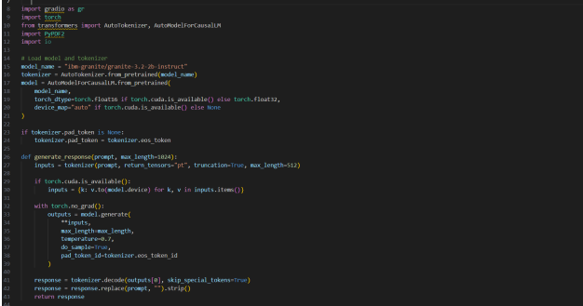

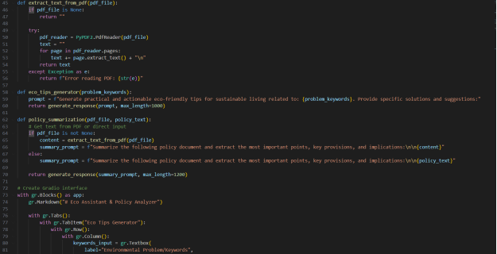

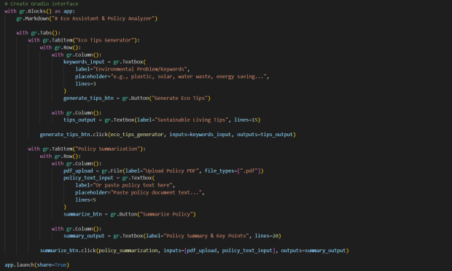

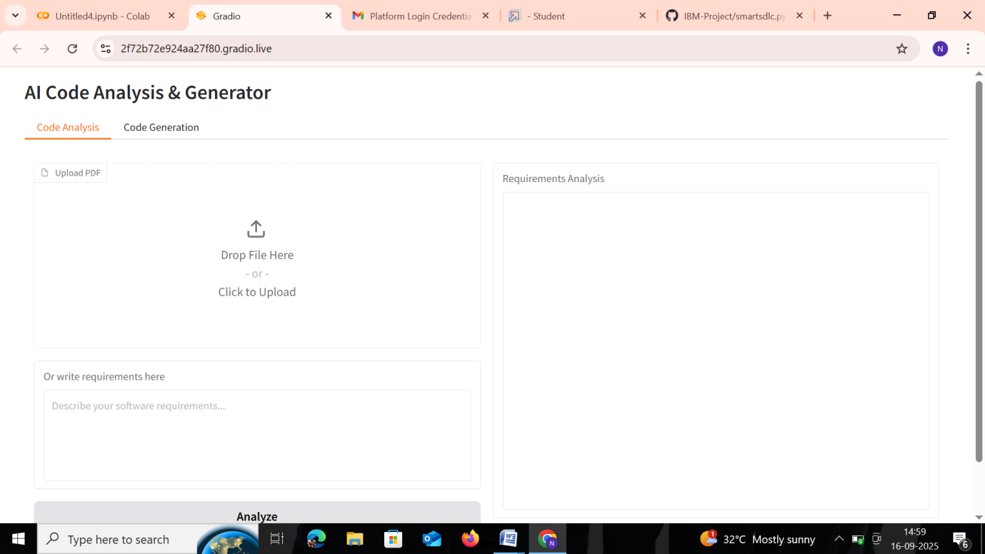

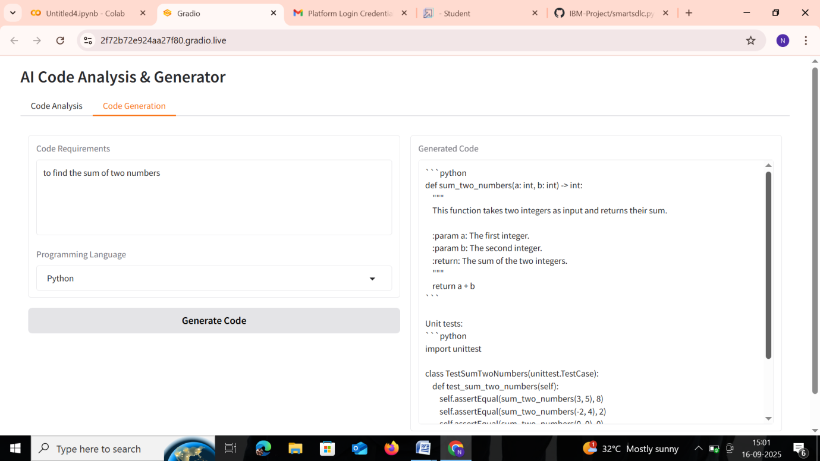

**8.Conclusion**

The Smart SDLC represents a significant shift from traditional software development models by embracing automation, intelligence, and continuous improvement. It empowers teams to deliver high-quality software faster, more securely, and with greater alignment to user needs. By integrating Agile practices, DevSecOps, AI tools, and real-time feedback mechanisms, Smart SDLC not only accelerates development cycles but also ensures adaptability in a rapidly changing technological landscape. Organizations that adopt a Smart SDLC approach position themselves for long-term success through improved collaboration, reduced risk, and enhanced product value.